Priory Court
Extra Care housing for older people

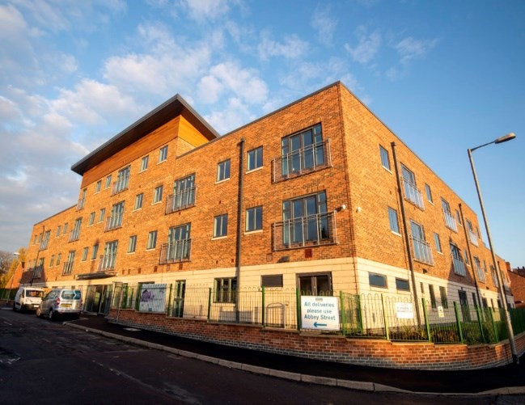
Priory Court in Worksop is a purpose-built extra care scheme for older people who want to continue to live independently. This scheme allows them to stay in a home with its own front door and private space whilst having the additional communal facilities and personal care support available.

Local amenities include an excellent bus service with bus stop close by, close to Worksop town centre and Worksop library, Savoy cinema and Priory Church.

There are 52 spacious and accessible flats which are designed to meet people’s needs with level access showers, wheelchair turning circles, and accessible kitchens. A lifeline call system is provided in every flat which gives residents the reassurance of being able to seek assistance if needed. There is a lift for access to upper floors

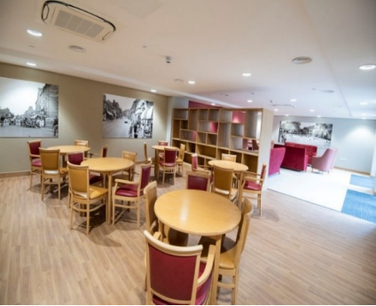

Facilities include:
- Secure door entry system
- Communal lounge and kitchen
- Communal Library
- Laundry Room
- Activity Room
- Assisted bathing facility
- Scooter store and charging facilities
- Shared communal garden
- Guest room which can be booked by visiting family

Of the 52 flats, 37 are Extra Care flats for people who have been assessed as having care and support needs.

Extra Care
Extra Care is a housing option which allows older people to live as independently as possible with the reassurance of support with personal care on site as needed. It is also sometimes also known as Housing with Care.

People living in these flats have care and support provided by a care team that is on site 24 hours a day, 7 days a week. This service is arranged by Nottinghamshire County Council for people who meet the criteria.

To be considered for one of the Extra Care flats, you will need to be assessed by Nottinghamshire County Council as eligible for social care support. Your savings and investments must be below the threshold of £23,250.

You will also need to apply to Bassetlaw District Council for a tenancy.

How much does Extra Care cost?
There are three parts to the cost of living in an Extra Care flat:
- Housing – the cost of renting your home. This is payable directly to Bassetlaw District Council. You would also pay your own utility bills
- Service charge – for housing related support and communal facilities. This is payable directly to Bassetlaw District Council.
- Care and support costs – the amount you need to contribute to the cost of care will depend on your financial circumstances. This is payable to Nottinghamshire County Council who will complete a financial assessment to work out exactly how much you can afford to pay. The whole amount of the assessed contribution would be payable

Further information regarding paying for care can be found on the Nottinghamshire County Council website: http://www.nottinghamshire.gov.uk/care/adult- social-care/paying-for-care

To speak to someone about Extra Care, or to arrange for an assessment, please contact Nottinghamshire County Council on 0300 500 80 80.

General Needs
There are also 15 flats for people who do not have the Extra Care service.

If you would like to know more about Priory Court, or would like to express an interest in renting one of the general flats please contact Bassetlaw District Council:

Phone: 0800 590542
Email: customer.services@bassetlaw.gov.uk
Website: www.bassetlaw.gov.uk
We are committed to protecting your privacy and ensuring all personal information is kept confidential and safe. For more details see our general and service specific privacy notices at: https://www.nottinghamshire.gov.uk/global- content/privacy

